Profound Mimesis: A Defense of Literature
By Marcia Eppich-Harris
Delivered in the Last Lecture Series, Marian University
December 11, 2015

Thanks for coming, guys. I’d like to thank Aaron Wilder and Katie Jones, Danielle Santos, and Nancy Doll for setting this up today, and asking me to be the guest speaker. Today, I have a lot to say, but I’ll be talking mostly about the thematic subject in my title, which is Profound Mimesis: A Defense of Literature. If you’ve been in Humanities, you know what “mimesis” is --it’s imitation, right? It’s not especially ground breaking for me to say that literature is mimetic, especially since Aristotle said that 2300 years ago. But he was talking about a particular kind of literature (drama), and I would say that we think nowadays that all literature is mimetic, that it has to recognizable, and that for it to be recognizable it has to imitate “real” life, even if it’s fantasy literature. So how that recognition comes about is writers witness the human condition, and they think about it, and then they put it into words. So I am starting with an assumption that I, at least, believe to be true: that Literature reflects and imitates life. If we think about what Shakespeare says about drama, and how drama holds the mirror up to nature, we could apply that more broadly to literature in general – that literature shows us who we are. And if this claim is true, that literature shows us who we are, and reflects our values back to us, then we should pay attention to it if we care at all about knowing who we are as individuals, as a society, and as a culture.
You know, this knowledge of self may seem very obvious, and some of the things I’ll say today sound pretty obvious. We think that we know ourselves pretty well in this era of social media, selfies, but just because you take a selfie of yourself doesn’t mean you know yourself, right? How much do we know ourselves in the context of culture? In the information era, we could use a bit of a wake-up call about the self. We are more interested these days in displaying the self than contemplating the self. And when it comes to education, we talk a lot more about the utilitarian value of education, than we do about the meaningful acquisition of it, the meaningful acquisition of knowledge. In other words, I hear all the time, “How is this class going to get me job? What does this have to do with my life?” If we make our education system and our acquisition of knowledge teleological driven, meaning that there’s just one goal that we’re driving to, then what that means is we’re only setting ourselves up to achieve one thing, and that may be a job and consequently money. And try as we might, we feel like … we feel lost. America as a culture, I believe, does not emphasize enough what is actually important, and to me, what is actually important is having a meaningful life. How you obtain that meaning is up to you, but I, of course, have some suggestions. I think that having a meaningful life starts with education. But I think what our education system should do is not train you for a job, but to give you the tools to have a meaningful life, and to develop as a HUMAN being, not just until you are 22 years, but for the rest of your life.
Now you might ask, what are these tools in this toolbox? Probably the best answer I can think of can be found symbolically organized in one story that you’ll probably all be familiar with: The Wizard of Oz.
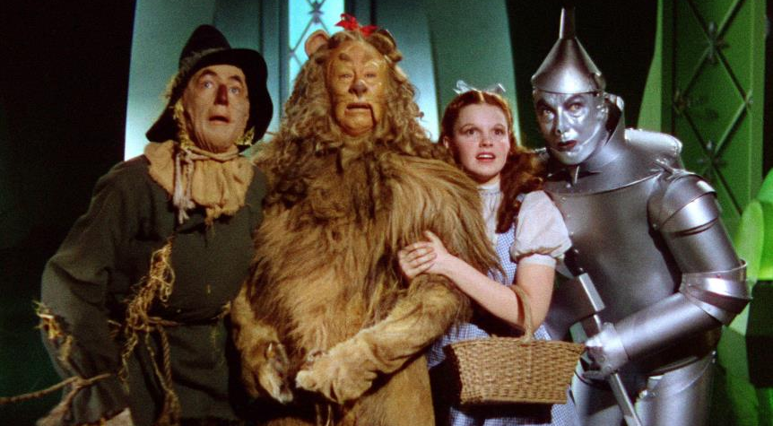
The Wizard of Oz is a fantastic allegory for the tools you need for a meaningful life. The Scarecrow, the Tin Man, and the Lion are pretty obvious. They symbolize intellect, love, and courage. I believe that to have a meaningful life, you need all of three of these things. But you also need to embody Dorothy a little bit. And Dorothy is on a journey, right? She might not be quite obviously symbolic, but she is on a journey and all the while she’s learning new things. She’s participating in things she’s never done before. She’s learning things she never knew before. And to me, Dorothy is a symbol of curiosity. And to be educated, I think you need a hunger and a thirst for learning, and that hunger and thirst is curiosity.
So I am organizing this talk based on the three tools that I think the Wizard of Oz gives us: intellect, love, and courage, and so we’ll be thinking about those things as we move along.
We’re going to start with the intellect.
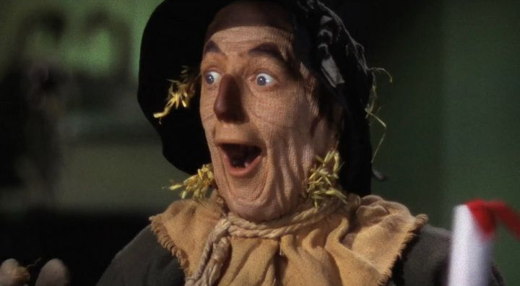
I love this picture of the Scarecrow because to me it signifies that light-bulb moment, where you’re so shocked and surprised by something that you learned and you had no idea you had it in you. But you finally understood. I’ve had lots of these light bulb moments in my life. I remember when I was at Indiana State for my master’s, I took a Shakespeare class because I was not an English major in my undergrad, I was a music major, and so I had some deficiencies that I had to make up for in order to be fully admitted to the master’s program. So I took a Shakespeare class, and that was one of the requirements to be fully admitted to the program. So I took it. The dean of the college taught the class – his name was Tom Sauer. Incredible man – so engaged, passionate, just amazing. He taught this class only on Tuesdays and Thursdays at 8:00, and I can tell you this is the worst, worst time of the day for me to be alive. 8:00 in the morning, I am barely alive, in fact at 10:00 this morning, I felt like I was not really here. Anyway, so I took this class, and my husband, Aric, is here and can verify that every day I said, “(sigh) I hate this.” And maybe I said something even worse. But I went every single day, and I loved the class, and I loved the reading, and I loved the teacher, and I was so inspired. And my whole semester was me looking like this – me looking like the Scarecrow – the whole time. And so Shakespeare for me became the light bulb going off at an alarming rate.
There’s a quote from Merchant of Venice that kind of symbolizes what Shakespeare is to me. In Merchant of Venice, Portia has dressed as a man, has gone to court, impersonated a lawyer, and helped Antonio escape the villain Shylock, who wants a pound of flesh for this bond that he has created and has been forfeited [by Antonio], and Portia saves the day, all that good stuff. And then she comes home from that, and you think, kind of, that Act 5 of Merchant of Venice is sort of a superfluous tag-on, because the main conflict has been solved. Shylock did not get his pound of flesh, blah, blah, blah, right? But when Portia comes home to Belmont, after having gone to Venice to support her husband and his friend, she sees a candle burning in her hall, and she says:
That light we see is burning in my hall.
How far that little candle throws his beams!
So shines a good deed in a naughty world.

Shakespeare is my candlelight in the darkness. I tell you, there are some people who when they are in a crisis, or they have a bad day, or they don’t know what to do, they’ll go to their mom, or they’ll go to the Bible, or they’ll go to a counselor, or a priest or whoever. And when I have a moment of crisis that I don’t know what to do, I go to Shakespeare. This can be easily exemplified by when my father died. I kind of just went to my bookshelf, not really thinking, and the first thing I grabbed, without even noticing, was Hamlet. (And I promised the Humanities people I wouldn’t talk a lot about Hamlet) but I just want to say that reading Hamlet when your father unexpectedly dies – it’s the experience of a lifetime, because you understand why he’s so upset for the first time. If my mother had married somebody the first month after my father died, I probably would have killed her, just because I wouldn’t have understood. I mean, I know the Renaissance is different and there are circumstances and everything, but why read Shakespeare if you’re not bringing your own experience to it? And so I understood Hamlet in a way that I had never understood it before. I had this Scarecrow moment where I was GASP!! And it made me feel very comforted. Very comforted.

But you know, the real sticking point for me in Shakespeare, the reason I keep coming back to Shakespeare, actually, is my permanent fascination with the history plays, and the use of the prodigal son narrative in Henry IV, part 1, part2, and Henry V.

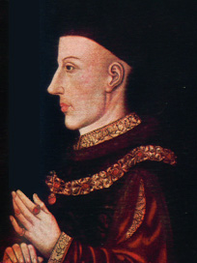
This is about a real king, this guy, Henry V, and he starts out his career in Shakespeare as Prince Hal. Prince Hal is in kind of a sticky situation – his father has usurped the throne, and in order to feel like he has his own identity, he ends up distancing himself from his father, and he does that through sort of creating, manufacturing, his own prodigality narrative. He knows that his reign is going to be difficult, so he devises a plan to become a pretend prodigal son, and then to reform his life, in order to seem like he has made a great come back. In the very beginning of the first play that he is in, he says these words:

…Yet herein will I imitate the sun,
Who doth permit the base contagious clouds
To smother up his beauty from the world,
That, when he please again to be himself,
Being wanted, he may be more wonder'd at,
By breaking through the foul and ugly mists
Of vapours that did seem to strangle him.
If all the year were playing holidays,
To sport would be as tedious as to work;
But when they seldom come, they wish'd for come,
And nothing pleaseth but rare accidents.
So, when this loose behavior I throw off
And pay the debt I never promisèd,
By how much better than my word I am,
By so much shall I falsify men's hopes;
And like bright metal on a sullen ground,
My reformation, glittering o'er my fault,
Shall show more goodly and attract more eyes
Than that which hath no foil to set it off.
I'll so offend, to make offence a skill;
Redeeming time when men think least I will.
(1 Henry IV, 1.2.63-85)

And it works. Henry V becomes one of the greatest kings of all time in England, because he uses his intellect – because he uses his intellect – and he makes a plan, and he figures out how he can make his power even more powerful through mimesis, through imitation. He says he going to imitate the “sun, which hides behind a cloud,” but that choice of words, “I will imitate the sun” you would hear in the theatre, right? And so, it contains a pun. “I will imitate the sun.” What “sun”? The prodigal son. The one who goes off and is an idiot – he drinks and has prostitutes and all this business, wastes all of his money, and then he comes back and reforms and all’s well that ends well, right? In saying that he’s going to imitate the sun, he’s not just using a metaphor for the celestial sun, which is the metaphor of kings, but he’s saying that he’s also going to imitate the prodigal son, which is essentially what the rest of the speech tells us without bringing up the Bible at all. You could try to take that metaphor further if you want and say that Prince Hal wants to imitate the son of God; he calls himself a Christian king, and people call him the “greatest Christian king,” but I think that Prince Hal’s actual actions are very much not Christ-like, so I wouldn’t go that far. But by gosh, he can do a prodigal son, like nobody’s business. So he repents, [but first] he hangs out with this old, drunk, fat knight named Falstaff, and they get into all kinds of trouble. They go on this highway robbery thing, and his father is like, “When are you going to get your act together? You’re the heir apparent, blah, blah, blah.” But Hal does reform himself. He uses his amazing rhetoric; he’s really great in battle; he proves himself time and again. And voila! You’ve got a reformed king and everybody thinks he’s great.

It unbelievably works. Unbelievably. And you know what’s funny is that Henry V keeps coming up in pop culture, in interviews – I saw an interview with Daniel Radcliff, who play[ed] Harry Potter, and he said about Harry Potter that he’s a bit like Henry V. You could have knocked me over when he said that. So even now, it seems, people in the UK think fondly of a king from the 15th century that Shakespeare wrote about in the 16th century. Isn’t it amazing? And it’s because of his prodigality narrative – his ability to use literature to change his own life, which changes not just one but two nations. Isn’t that amazing? Sometimes imitating literature can have an incredible impact. For Prince Hal, that incredible impact of literature is not just personal, it’s political, and he uses that intellect in lots of different ways. Of course, we know that the prodigal son – he comes back, his father’s going to forgive him and everything. Prince Hal has so much faith in that story, so much faith in that mythology of the prodigal son that he uses it in order to make himself mythical. It’s a prime example of how knowing about literature and imitating story can have an impact across the world.

Now, another person that I think uses his intellect in order to impact the world is a writer named Viktor Frankl, and he’s not just a writer, he’s a psychiatrist.

He was a survivor of a concentration camp – not one, but many actually – and he uses his intellect to find a way to make meaningful lives in the midst of the most miserable of circumstances, which I can’t think of many things more miserable than a concentration camp. I often think of literature is a thing that can save me, can make me feel comforted, can make me change my attitude, and Frankl’s book is one that I need to read approximately once a year in order to have a mental cleanse. Frankl is one of those who comes and saves me once a year. He says that you can gain meaning in your life through three different things: work, relationships, and overcoming suffering. The overcoming suffering part of the triangle is what we see in literature from Gilgamesh all the way to Stephen King. Few people want to read books that are about work. Many people want to read books that are about love. Lots of people want to read books that are about overcoming suffering, because it gives people hope: “If this guy can get through this, then maybe I can get through finals week.” Right? And it also gives people courage -- the courage to continue. To know that other people are suffering makes us feel like we’re not alone, makes us feel like we too can triumph, and Frankl says that overcoming suffering can happen in the simplest of ways: by changing your attitude. He says, “… Even the helpless victim of a hopeless situation facing a fate he cannot change, may rise above himself, may grow beyond himself, and by doing so change himself. He may turn a personal tragedy into a triumph” (146).

Now, it takes an incredible amount of reasoning with yourself in order to accomplish the feat of using your intellect to change your attitude about something, but there are true benefits to doing so. One of the examples that Frankel uses in his post World War work strikes me as particularly poignant. There was a woman who had two sons, and one of them died at the age of eleven, the other one was in a wheelchair. The woman’s so overcome with grief with the loss of her healthy, otherwise healthy, son that she cannot imagine having a meaningful life without him, so she decides to commit suicide and she’s going to take her wheelchair-bound son with her. It’s a horrifying thing to read as a parent, because it’s terrible to think about killing your own child. The wheelchair-bound son stops her. He says, “I like living,” and she didn’t get it at first, but she thought – she couldn’t imagine having a meaningful life in a wheelchair, but she realizes that she had made a difference in her paraplegic son’s life by taking care of him, by reading to him, by making sure he wasn’t alone. She could have put him in an asylum or whatever they called it in the early part of the 20th century, but she stood by him. These were things that made him feel happy, made him feel like he had a meaningful life. When she realized that she had made a huge difference and had given her son meaning in life, she no longer wanted to die. She changed her attitude. She realized that her efforts were not in vain and that her relationship with her son and the suffering that they were going to go through together would compensate for the loss of her other child.

The alternative to changing your attitude is pretty depressing -- you just sit there and wallow in it. Another theorist quoted in Frankl’s book talking about logotherapy, which is Frankl’s term for a “meaning centered therapy” says, logotherapy “may help counteract certain unhealthy trends in the present day culture of the United States, where the incurable sufferer is given very little opportunity to be proud of his suffering and to considerate it ennobling rather than degrading,” so that, “he is not only unhappy, but also ashamed of being unhappy” (Man’s Search for Meaning, 146). That’s a really terrible cycle isn’t it? Not only to be unhappy but to see all these people – and we see this, I mean, that quote is from the 1950s, but we see more and more and more the people on Facebook and Twitter that only show us their happy days, that only show us their perfect adventures. We are not allowed to suffer and struggle and be unhappy, and if we do those things and do them publically, we also need to be ashamed of ourselves for not being happy. I think that that’s terrible and untrue. We should not be ashamed of ourselves for living life as a human being. But there needs to be a change of attitude about that, right? We need to find an alternative to helplessness.
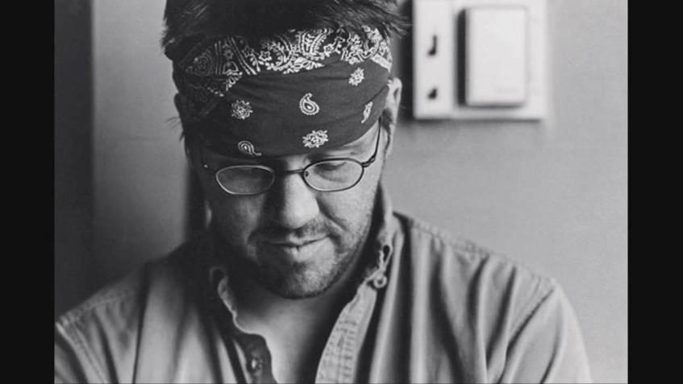

Dave Foster Wallace, I think, has a great bit of advice about this in his Kenyon College Commencement Speech, which I actually do teach in Humanities, so I’ll just briefly mention this. Wallace says that education is not about our capacity to think, but rather to choose what to think about. He says that our problem in our society is that we are stuck on our default settings. What that means in computer speak, default settings, is that you just haven’t changed anything. All the settings are like “print on one side,” and “print horizontal versus vertical” or whatever – the default settings are the things that come with the computer. But if you default on a loan, it means you failed to pay a loan, right? The word “default” is important because it means there’s a failure somewhere. So a default setting means you have “failed to change,” and in our lives, Wallace is saying that we are all stuck on our default settings. We fail to change; we fail to choose otherwise. He says real education is about being well adjusted, but more importantly, you get to decide what your attitude is. You get to consciously decide what has meaning and what doesn’t. “You get to decide what to worship,” [he says.] “The really important kind of freedom involves attention and awareness and discipline, and being able truly to care about other people and to sacrifice for them over and over in myriads petty, unsexy ways every day.” He goes on to say that “this is real freedom, understanding how to think. The alternative is unconsciousness, the default setting, the rat race, the constant gnawing sense of having had and lost some infinite thing.”

In closing about this section, I think we need in our quest for a meaningful life to think about our failure to change and our failure to change our attitudes and to use meaningful things to us to help us get through our suffering.

Now, lest you think I’m not going to talk about the other two touchstones, let’s talk about love.

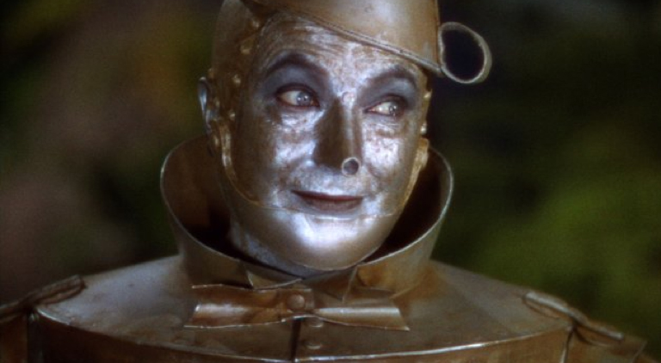
I admit that I both love and abhor love stories. It’s kind of sad. I was considered very emotional as a kid, and that seemed to be an unattractive trait in some ways. I’m actually pretty happy that I grew up when I did, because I had time to work out that issue and those demons myself instead of being drugged into oblivion like a lot of kids are these days. But I had to learn to control my emotions. I wish my son, Kai, would. He’s just like me. He’s a tornado. I was mostly able to get my emotions in line, but romance stories open floodgates for me and allow that pent-up feeling to take over. It’s a little scary I hate to say, and it’s because love makes you feel so vulnerable. You never know when that vulnerability is going to open you up to pain. But I started to allow myself to be more emotional when I finally found the right person to share my life with, and that is my husband, Aric, who just happens to be right there.
I just want to share a little bit about how I met Aric, because I think it’s a kind of interesting story. We actually met online before that was a thing. We met online in 1999, and he was living in Michigan and I was living in Indiana. We just chatted for a week, and I said, “You’re really cool. Let’s get together and hang out,” and we did and that was it. October 16th, 1999, and for the rest of my life, this guy, because Aric was the kind of person who would allow a vulnerability with the intention to never hurt. Never use something against me. Pro tip – I screw up all the time, but unlike my family of origin which would badger me and make fun of me about screwing up like, “oh, you did that? Ha, ha, ha!”Aric would be like, “Oh, you did that? That sucks. I’m sorry,” and be the kind of person who could allow me to be who I am. I was thinking about that as I was putting together this lecture, and so I started thinking about Audrey Niffenegger’s book The Time Traveler’s Wife, which is a really dramatic novel, but I love it.
My books at my house are not arranged alphabetically, not arranged by subject, not arranged by author. They are arranged by least to most embarrassing. So all the things you can see at your eye level are things I should be reading – Shakespeare, history, and theory books. At the bottom of my bookshelf are the Twilight books, and Time Traveler’s Wife, and things like that.

If you don’t know this book, it’s about two main characters, Henry and Claire. Henry has a disorder that makes him spontaneously time travel, and he cannot control it. So he spontaneously time travels to a different time and place in his life. When I read this book, it was at a very particular moment in my marriage, in 2005, when Aric had lost his job, and he connected with an alum of Marquette – you all should keep in touch with your alumns, I tell you, they’ll get you jobs – he connected with an alumn at Marquette, and he got offered a job in California. We were living in Wisconsin. California sounds better than Wisconsin when you’re in zero-degree weather nine months out of the year. Anyway, I was pregnant. We decided to take the job and move to the Bay Area, and I read this book in the month that we were separated. He had to move out in July, and I had to stay behind and pack our lives and then move out in August. This book is about how Claire copes with being away from her husband because he’s spontaneously gone all the time, and they try to have a child together. She has six miscarriages, and when I was reading this book, I was nine weeks pregnant, freaking out about it. I mean, I was happy about it. I wanted to have a baby, but I was freaking out about money and everything. So she keeps having miscarriage after miscarriage and they’re separated and they love each other so much, but they can’t be together, and I just keep thinking about Aric, and this book is like 600 pages long, and so I was reading it and crying and reading it and crying and reading it and crying. And even though the critics say this is a melodramatic, kind of contrived book, I loved it because of the emotional depth and the characters were going through a thing that I was feeling like I was going through. To me, it was profound mimesis. Profound mimesis. It felt like there were times that I was struggling with problems that were completely out of my control, and Claire has no control over whether her husband is there or not, whether their child is going to survive or not and so on. She is forced to deal with Henry’s problems all by herself, and I felt like I was having to deal with my problems all by myself. And the wonderful thing about our relationship is that we never face anything alone. So this was a really different kind of problem to me, being alone after I had been with someone who was so there for six years and we were having a baby and living our lives. But all’s well that ends well. We got back together. We drove out to California together. It was the most amazing, romantic thing because we had been separated for a month, and I had read this book and cried and cried.
One of the things that strikes me as very true in this book is this quote: “Our love has been the thread through the labyrinth, the net under the high-wire walker, the only real thing in this strange life of mine that I could ever trust” (503). This passage may not be especially beautiful, and maybe you think it’s a little bit trite, but when I read it the first time, and the subsequent paragraphs that reference Odysseus – or Ulysses – and how Penelope has to wait for him to come home, my separation from my best friend and the love of my life was not just a month-long inconvenience, it became a part of an epic, an epic narrative of women who love with ferocity and they will do anything to be reunited with their love. That mimesis helped me through an incredibly difficult time, and that book made our reunion even sweeter in the end.

Another love story that I find to be interesting and also a story that allows you to become who you really are is a play called Tribes by Nina Raine.

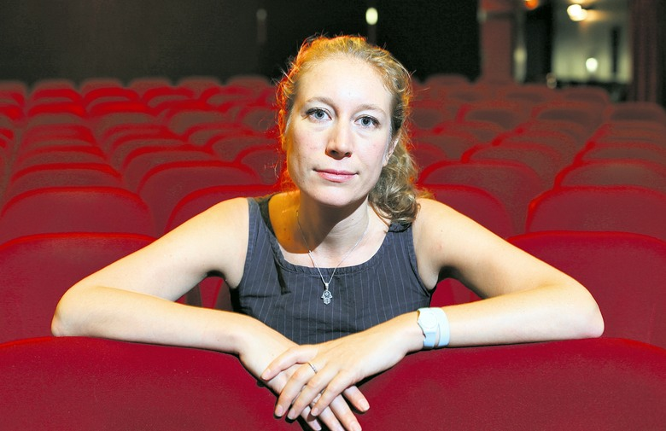

It’s about a boy named Billy who was born hearing impaired. He never learns sign language because his family didn’t want him to think or feel like he was any different from them. And yet, because of that, he feels very isolated and doesn’t really communicate, doesn’t really have friends, and even in his family, they talk all around him, but he’s barely able to keep up because he’s lip reading and he can’t [mimes quickly looking back and forth] do that all the time. Shift around his head. So he meets a woman named Sylvia who is not deaf. Her parents are deaf, and she is going deaf. She had been hearing her whole life and she starts going deaf. She teaches Billy how to sign and they fall in love, and he’s able to become fully who he is because of Sylvia. He is no longer a ghost in his own family. He demands that they learn to communicate with him so he can be a full participant in their lives.

I feel like love does this to you. It makes you become who you were meant to be all along. Now this story doesn’t necessarily have a happy ending, because Billy and Sylvia break up, but I think the key thing is that she unlocks him. He’s almost in a coffin his whole life and she opens up the lid. When you have someone do that for you in your life, you finally become who you were meant to be. How literature and how mimesis interacts with [life] is when you first meet someone and you start to find out who they are, you tell them stories. You tell them your stories of your childhood; you tell them stories of your life. You tell them stories about people you know. Those stories are the things that make you fall in love. Without stories, there’s no love. Without an imitation of life, there’s no love.

That brings us to courage, which I think of the three organizing principles of a meaningful life I think courage is the most important.

Without courage you’d never use your intellect for anything substantial. You’d keep it to yourself. You wouldn’t talk in class; you wouldn’t show off what you know. You wouldn’t use the word “mimesis.” Without courage, you’d never tell someone that you loved him or her. It takes a lot of courage to say “I love you,” because putting yourself out there and saying “I love you” is just asking to be rejected. It’s just asking for it. But courage is useful in lots of other little petty ways. Courage makes you leave the house in the morning, even though there are lots of murders in this city right now. I mean, what is going on? Courage lets you drive a car, even though people get in accidents every day. Courage allows you to live your every day, boring life. It allows you to get on with life. There are a lot of stories about courage. In fact, I would say literature is driven by the desire to document courage. One of the books that speaks to me a lot about courage is the novel Gone with the Wind.

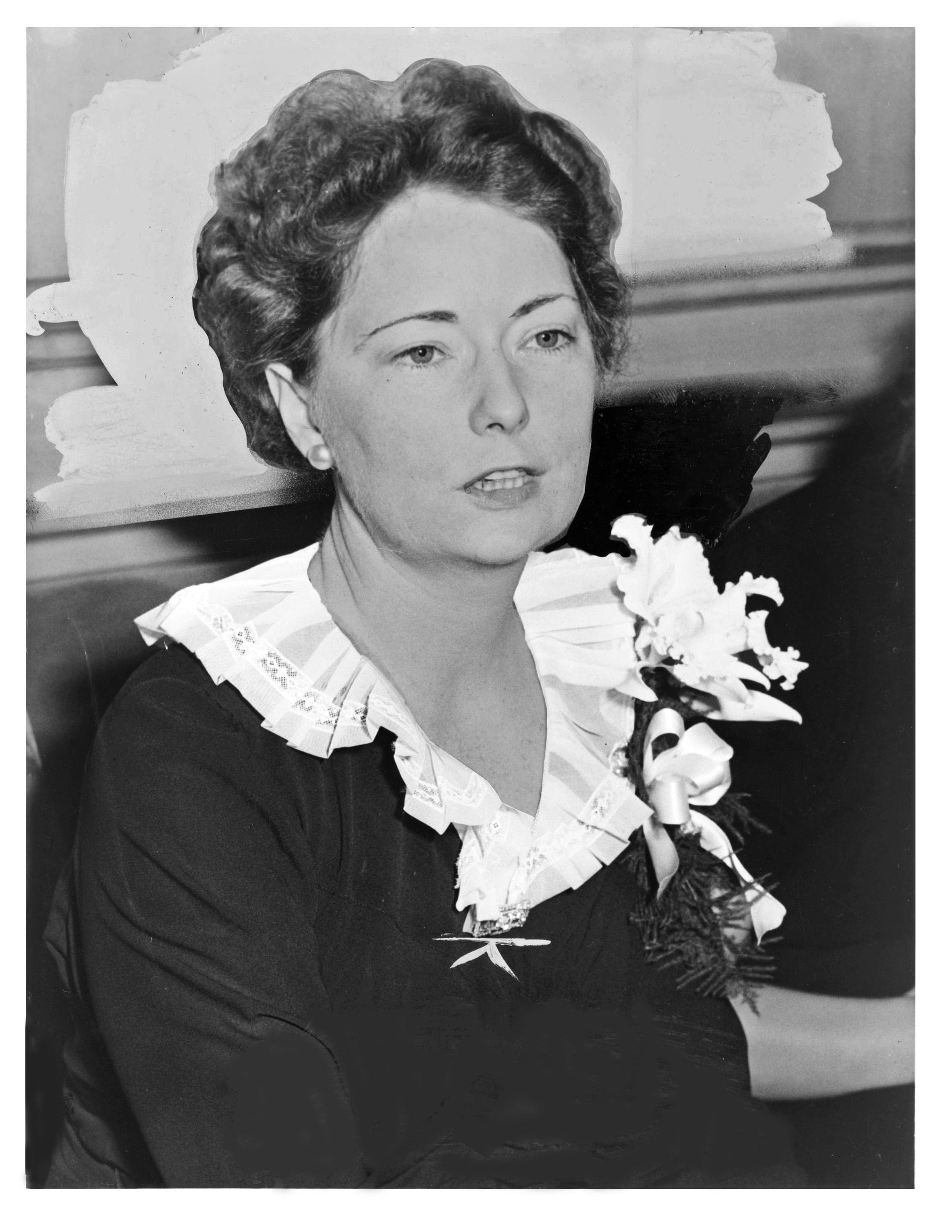
Gone with the Wind is a bit of a controversial novel because it’s about the south in the Civil War, and it’s got slavery, unabashedly talking about slavery, and it’s got the southern belle culture, and the pride of the Confederacy. It has that stuff if you’re not looking very deeply into it. It is true that Margaret Mitchell was a woman from the south; she was from Atlanta. She died in 1949; the book was published in 1936. I have a first edition copy of it. I love this book. She was the granddaughter of people who fought in the Civil War, and yet, her two most compelling characters in the book, Scarlet O’Hara and Rhett Butler, both think that the war and the resulting rise of the Ku Klux Klan are not only foolish and misguided, but frankly stupid. When Rhett is asked at a lavish party at the beginning of the book to give his opinion about how the south will do in the war if they start fighting, he says, “All we have is cotton, slaves, and arrogance. They’d lick us in a month.” Now, the war lasts years, not a month, but Rhett’s frank comment about the South’s inability to win the war against the powerfully industrialized North sets him apart from all the other men in the novel. Ashley Wilkes, who is the third part of this love triangle of Scarlet, Rhett, and Ashley, also believes that the war is foolish, but he signs up right away and goes and fights anyway. Scarlet tells Ashley that she loves him. He rejects her and says he’s going to marry his cousin Melanie. [Gross] She pines after him throughout the entire novel, and Rhett is in love with Scarlet the entire novel, and he helps her many, many times throughout the novel. She marries two other men; she’s widowed twice, but Rhett keeps coming back, keeps saving her from the Yankees, helps her when she needs to share her frustrations. He helps her escape the burning of Atlanta.

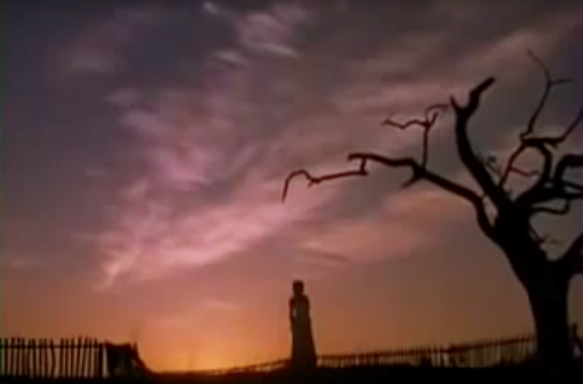
And yet, he also abandons her. He abandons her and goes last minute into the war, because he feels guilty.

Scarlet goes home to Tara, her plantation, where her mother has died, her father has gone made with grief. She has two sisters who are suffering from typhoid and there are a couple of slaves who haven’t run away – they stuck around. Scarlet becomes the head of the household, and she’s responsible for taking care of all these people, and of course, all of the other plantations have been burned down. Her house has been used as a headquarters for the Yankees. They’ve eaten all the chickens, all the cows, devastated the gardens. So she goes to a nearby farm and to the slave quarters, actually, where they have their own garden and she finds some food there. She’s so hungry that she grabs a radish, and she tries to eat it, but then she’s overwhelmed with nausea because she’s just eating something dirty out of the ground and also being so hungry, she can’t handle it and she spits it back up. She’s so devastated by that, and she has this moment where – a very famous moment from the movie – where she gets up from the dirt and she says, “As god as my witness, they’re not going to beat me,” you know, the Yankees and the situation is “not going to beat me.” The famous line is “As God as my witness, I’ll never be hungry again.” So she’s standing there, fist raised to the sky. It’s a four-hour movie, so this is where the intermission takes place. But she does what she needs to do to survive war, to survive Reconstruction. She manages to figure out a way to feed her family. In the movie, she only has one child – in the book she has three, one from each husband. She eventually marries Rhett. She has to take care of all these hungry mouths and how is she going to do that? In this time period, you know, the 19th century, women are running plantations and households and whatnot, but she’s 17, 18, something like that when this all happens. So she doesn’t know what the hell to do. She was going home to have her mother take care of her.

She sort of hardens her heart against the inevitable burden and she just takes it on and she just does what she has to do. In the movie she says the line, “If I have to lie, steal, cheat, or kill, as God as my witness, I’ll never be hungry again.” In the book, she just says, “If I have to lie or steal” or something like that – it’s only two of them. But in the movie, they say, “Lie, steal, cheat, or kill,” and she does all of those. She does lie, she steals, she cheats, and she does kill. She kills a Yankee scavenger soldier who comes to their house. She shoots him in the face and then buries him in the vegetable patch. Little fertilizer I guess. Anyway, there are all these supporting characters. It’s a huge epic novel. And you know, we would call this PTSD – the fact that she becomes just impossible to live with. She has nightmares. She’s sharp tempered. She yells at people. She hits people. She is awful to her children. She neglects them. They are very afraid and she’s like, “I don’t have time for this. Grow up,” and she says this to like her three-year-old. I mean, it’s crazy the way she treats people, and yet you know it’s because she has such a huge burden that she was not expecting and because she’s been through something so traumatic – seeing the city that she lived in burned and seeing her mother dead and her father mad and whatever. She eventually does marry Rhett Butler after her second husband dies in a Ku Klux Klan raid.

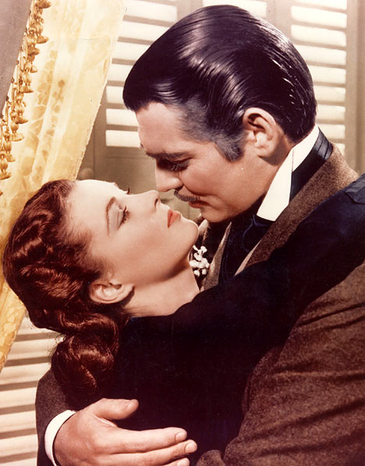
And when she finds out her husband was in the Klan, she was like, “What an idiot.” Seriously. So she never supported that. So she’s been married twice, widowed twice. She marries Rhett mainly because he’s rich, and Scarlet believes in her heart that if she just could compile a fortress of money, she would never, ever be hungry again. She’d be able to take care of herself, take care of her family, and never be hungry again, and also get the security that she’s missed since before the war. All along though, even though she marries Rhett, she’s still in love with Ashley.

I think that Ashley represents the thing, like how we get distracted by something we think is valuable but really is not. We often pour our hearts into certain objects and certain things that we think are valuable, but it’s all a lie. They never love us in return or give us back what we need. Rhett throughout the book is sort of the drumbeat of the person who gives her exactly what she needs – you know, the pragmatic logic, support. But they both play games with each other. He never wants to say that he really loves her because he thinks that she’ll use that to manipulate him, and he’s probably right. And neither one of them, even though she starts to realize that she’s got some feelings for him, she doesn’t want to be vulnerable because she thinks he’ll probably make fun of her, and she’s probably right. But ultimately neither of them has the courage to allow themselves to be vulnerable. They have the courage to take on the Yankee army, but they don’t have the courage to love each other.

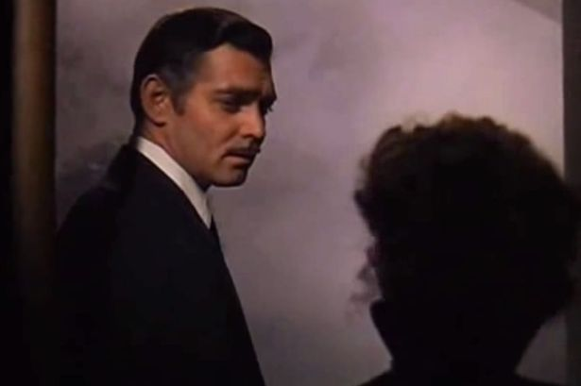
There are very great losses when your courage is used only to survive. There are a lot of compromises and a lot of sacrifices. If you merely have the courage to do what you must to survive, then you could lose everything that you care about, which is exactly what happens to Scarlet when she finally realizes that Rhett is the person she loves and who has taken care of her and who has allowed her to be who she is. Once she’s realized all that, he’s done. He leaves her. She says, “If you go, what shall I do?” And he tells her very famously what he thinks. Beforehand he tells her, “’I’m too old to shoulder the burden of constant lies that go with living in polite disillusionment. I couldn’t live with you and lie to you. I can’t even lie to you now. I wish I could care what you do or where you go, but I can’t.’ He drew a short breath and said lightly, but softly, ‘My dear, I don’t give a damn.’”

That is what deeply focused, tunnel-vision survival mode will get you. Isolation. Alienation. And people that don’t give a damn. Being focused on survival is not true courage. Don’t get me wrong. I’m very sympathetic to Scarlet and I am unsure I could have survived a war like that in tact myself. But what would have made Scarlet truly courageous is if she would have allowed herself to be vulnerable. Allowing love in your life is one of the hardest and also one of the most human things to do. But defending yourself against love is also very human because you’re afraid you’ll get hurt, and it’s certainly understandable. The tragedy is shutting out the perfect remedy, thinking you aren’t sick. When you’re dying, you understand what could have healed your wounds, but it’s too late. Having the courage to be vulnerable is incredibly hard, but it’s also incredibly important, if you want to have a meaningful life. I think love obviously takes courage, and relationships in general take a lot of courage.

But if you want to think more permanently about your legacy in life – you know the thing that takes more courage than anything when you’re thinking about your legacy? It’s writing.

Writing takes real courage.

I always wanted to be a writer, ever since I was a kid. In fact, when I first read Gone with the Wind, I was 12 years old. That’s pretty hefty book for a 12-year-old – 1000 pages long. When I read the book, I was so upset at the end. I cried, and cried and cried. So what I did was I sat down and I pulled out an old manual typewriter, and I wrote a sequel to Gone with the Wind in 1988, so that Scarlet and Rhett could get back together, because they were obviously meant for each other, right? In 1991, I think, Alexandra Ripley wrote a real, authorized version – a sequel to Gone with the Wind – hers was also very, very long. Mine was 150 pages. I got it done quick. Hers was like 800-pages long and not very good. But since then, I have written a total of four novels. I haven’t published any of them, but I feel like that’s okay. I’ll get it done eventually. Probably not the Gone with the Wind one. I can’t find it. This is before thumb drives and things.

Anyway, when I think about writing, I think about individual authors. You know, Stephen King is not a part of the literary canon; however, he has been one of the most successful writers in my lifetime, and his book called On Writing is so inspirational to me because it talks about his career and how he got into writing and used his imagination and came up with stories and how he got his first break with the novel Carrie. And it’s a really interesting story about how Stephen King became a writer. But the thing that strikes me the most about it is he is just a person. Isn’t that amazing to think that somebody like this prolific, millionaire writer, Stephen King, is just a regular dude? That makes me have lots of hope that any one of us could actually make an impact with writing. It takes a lot of work to be a writer. I mean, gosh, I’ve been working at it my whole life and I’ve only ever published a couple of short stories, and a poem. I’m not a huge fan of poetry, so I only sheepishly admit that. (Sorry Julie [poetry expert in the crowd].) Being a published writer is very difficult.

I remember when Aric and I first moved to California in 2005 – we were walking around, I was pregnant, I was very emotional, and we’re walking around this downtown main street of San Carlos, California, beautiful day, sunny, every day is beautiful there. We’re walking and walking. We’re not really saying anything. We’re just walking. And I stopped in the middle of the street and I said, “I want to DO something!” “What? What do you want to do?” And I was like, “I want to do something important. I want to make a difference. I want to write and, like, be admired and not even… I mean, who cares? But like, I want to make an impact, you know?” It struck me for the first time that, as I was growing a baby, that maybe it was important to think about that. That not only was I living my life for myself and my husband, but that I was living my life for a child all of a sudden, and that that meant that I was going to have a legacy whether I liked it or not. So I had better DO something. But what, I didn’t know. And how I could do it and how I could put it into words has eluded me for ten years. But I think it has something to do with writing.

You know, Stephen King says, “Writing is not about making money, getting famous, getting dates, getting laid, or making friends. In the end, it’s about enriching the lives of those who will read your work, and enriching your own life, as well. It’s about getting up, getting well, and getting over. Getting happy, okay? Getting happy.” (269) He goes on to say that his book On Writing, which is also not just a memoir of his career, but also the craft of writing, he says that there are risks to allowing your imagination to do its work. I heard a great quote on the Netflix show House of Cards, and I feel like this sums up everything: “Imagination is its own form of courage.”

You know, our imaginations are pretty amazing things. We’re the only animals on earth that create literature, that write it down, that preserve our histories. We’re the only creatures that do that. We just take it for granted. In the nation, there is a sort of war on Liberal Arts – that history is not important, that literature is not important. Who cares about history? Who cares about poetry? Who cares about… religion? Who cares about art? But if you think about it, we should be the ones caring, because all of those things in the liberal arts, they exist because we create them, because we imitate our own lives. Creation is a really fantastically interesting thing. You don’t really think about it until you’re actually creating something. You might create a sculpture, you might create a painting, you might write a book, you might create a website, you might do any of these things and think, “Okay, that’s good. I’ve got that done. Next thing.” But you took raw materials and made something that nobody else has ever made. Isn’t that kind of a miracle? Isn’t it kind of? I think that our unique ability to set down stories – what that means is that we make our imaginations immortal. Isn’t that amazing? That I will die, but this silly little short story that I created out of my imagination is alive forever? My imagination is immortal. So is Stephen King’s. So is William Shakespeare’s. So is Audrey Neffinegger’s. So is Margaret Mitchell’s. Right? But of course, I want to end with Shakespeare.

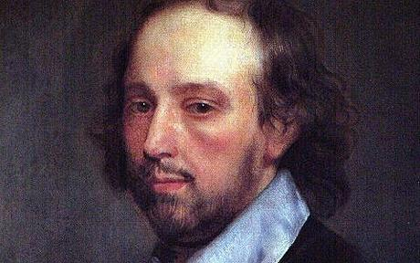

What do we do with this information?

If you know anything about the biography of Shakespeare you know he was not just a writer, he was also a reader. He stole every single plot that he wrote about. He was not creative in the fact that he was making up stories. He was adapting them. There is a creativity in adaptation, certainly, but Shakespeare wasn’t just a reader, he was not just a writer. He was also an actor – he was an actor.

One of the things that Shakespeare wrote is just a small quote from Cymbeline (of all places). He wrote: “Boldness be my friend, arm me audacity from head to foot.” Be courageous, be audacious. Believe that creation matters, because it makes you immortal.

I showed you a lot of pictures of authors, and I think that writers have to be courageous in order to do their work. They need to be vulnerable. They need to understand love. They need to be smart; they need to be logical, deeply aware of human nature and have the ability to imitate it.

I have a huge collection of books – huge. At home I have a huge collection of books. I have five bookshelves in my office. I collect books even though it’s more convenient to have an iPad or something that has all your books stored on it – ebooks, that sort of thing. But I collect books because I love having a physical representation of an author and his or her work sitting there with me. Books are so heavy. There’s a huge weight to them. There’s a feeling that there’s a cultural significance just in the physical object. And we need to understand that each one of those books, whether it’s a novel or whatever it is, each one of those books represents an individual’s undertaking. Now, of course there are editors, there are bookbinders, there are cover art illustrators, etc., etc. There are a lot of different people who work on books and put them together and make them look nice on your shelf. But a book starts with an individual and the desire to make imagination immortal, and we need to understand that that literature and writing are important because of the way they create our culture and show us who we are. But most importantly, that they make our imaginations immortal. Thank you.

